|  |  |  |  |
| --- | --- | --- | --- |
| **Name of Student: NINAD AVINASH PATIL** | | | |
| **Roll No: 33** | | **Lab Practical Number: 2(B).2** | |
| **Title of Lab Practical: WAP in C# to sort the data (Integer, Double, String) using Generics.** | | | |
| **DOP: 03/03/2021** | | **DOS: 10/03/2021** | |
| **CO Mapped: CO1** | **PO Mapped: PO3, PO5, PO7,**  **PO12, PSO1, PSO2** | **Faculty Signature:** | **Marks:** |

**Practical No 2(B).2**

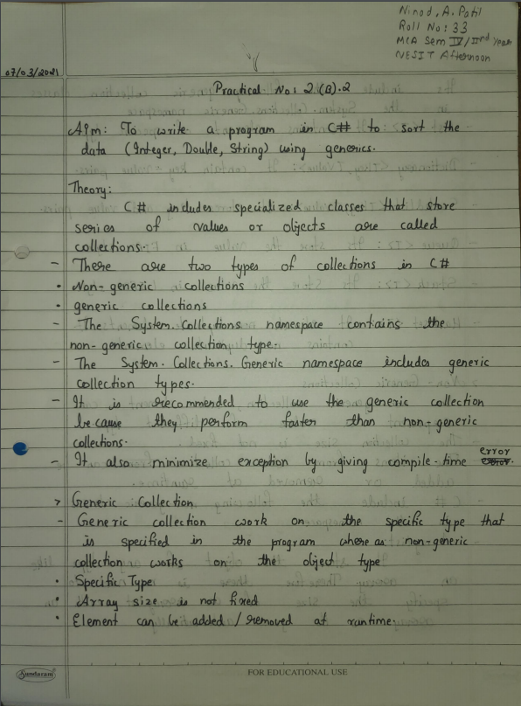

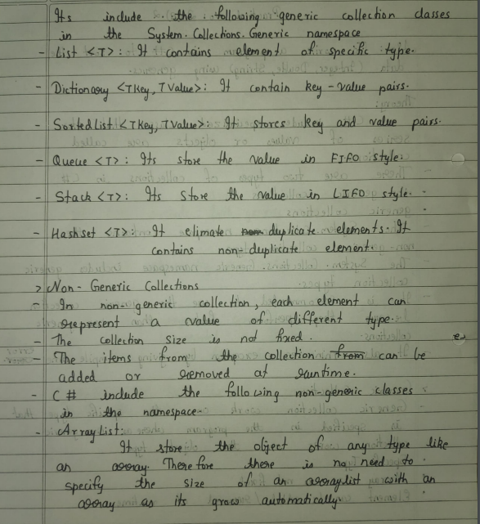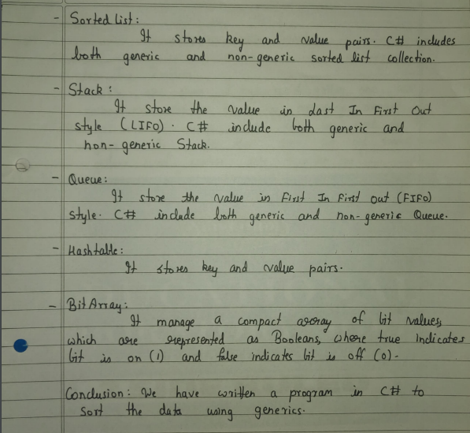

**Code:**

using System;

using System.Collections.Generic;

using System.Linq;

using System.Text;

namespace ConsoleApplication3

{

class Test<T>

{

T[] value1;

public Test(T[] t)

{

this.value1 = t;

}

public void Write()

{

Console.Write("Before sorting of an array : ");

foreach(T a in value1)

Console.Write(a+" ");

Array.Sort(value1);

Console.Write("\nAfter sorting of an array : ");

foreach (T B in value1)

Console.Write(B + " ");

Console.WriteLine();

}

}

class Program

{

static void Main(string[] args)

{

int[] a = { 31, 35, 32, 34, 33 };

double[] b = { 12.20,12.16,12.12 };

string[] c = { "Red","Blue","Yellow"};

Test<int> test1 = new Test<int>(a);

Console.WriteLine("Integer Sorting");

test1.Write();

Test<double> test2 = new Test<double>(b);

Console.WriteLine("\nDouble Sorting");

test2.Write();

Test<string> test3 = new Test<string>(c);

Console.WriteLine("\nString Sorting");

test3.Write();

Console.ReadKey();

}

}

}

**Output:**

